Tutorial 6.4

Stan Wan

## Step 1&2 – Simulation and Time-varying heatmaps

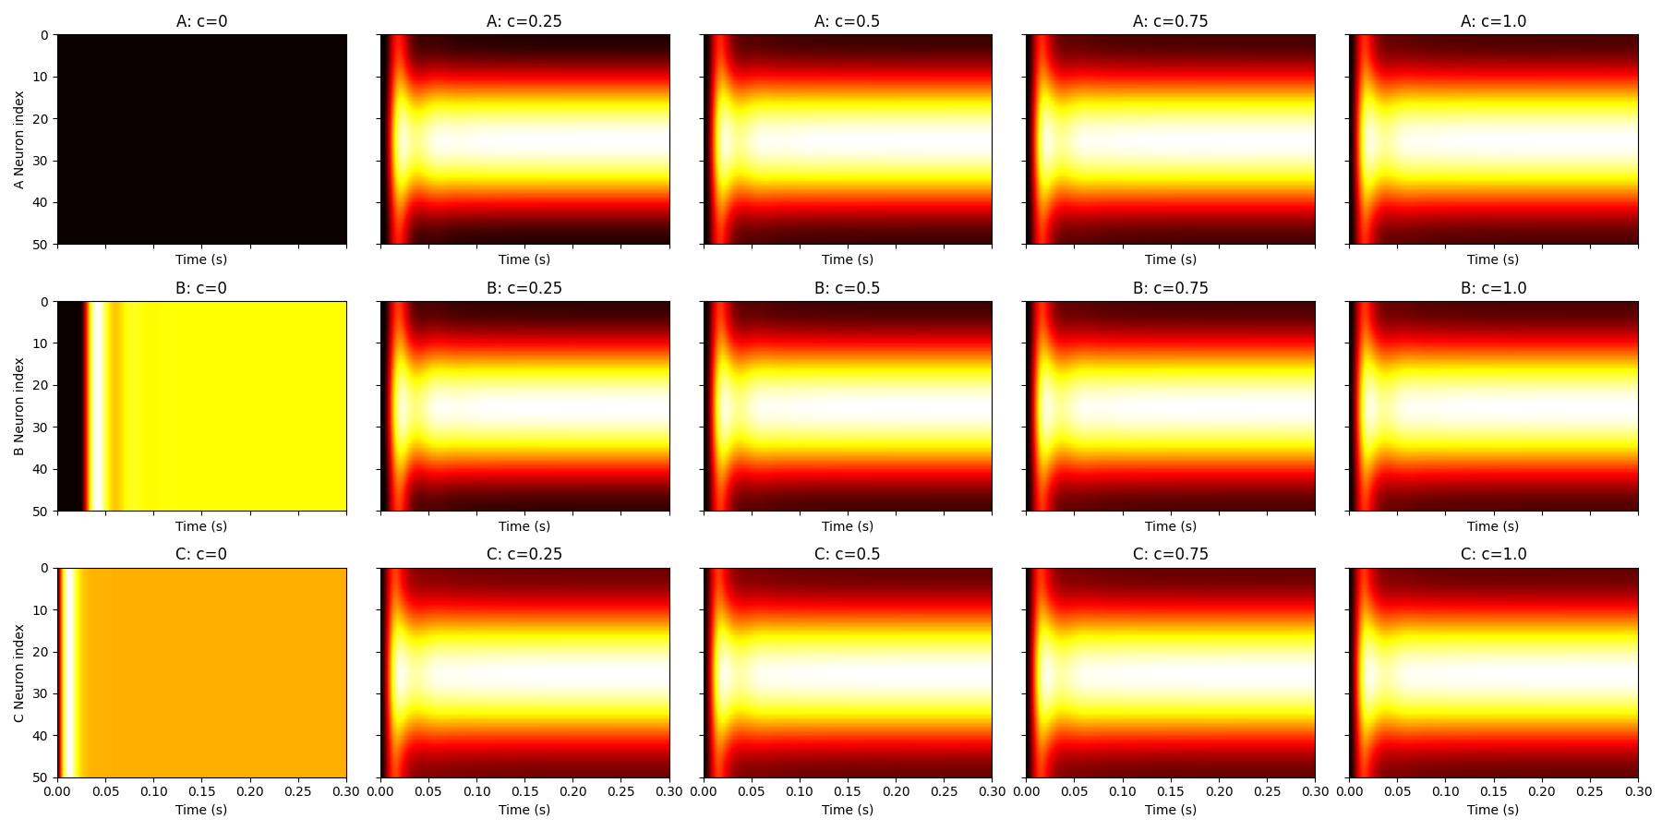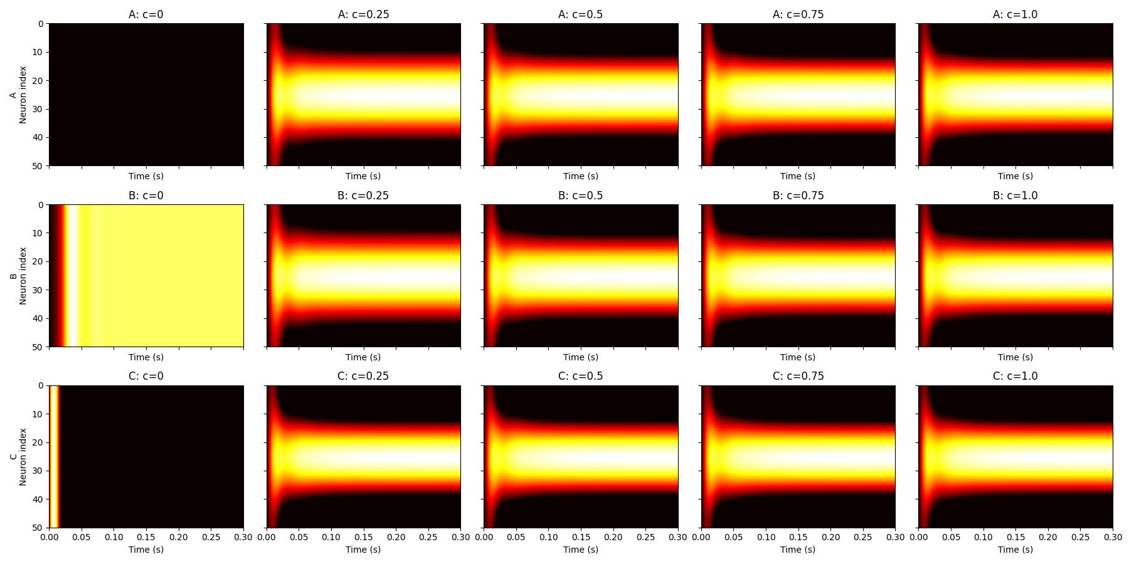

Shows excitatory firing rates over time for 50 neurons in each network at 5 contrast levels. Created by plotting rE(t) as heatmaps per network/contrast.

Network A shows no activity at c=0. B has baseline firing due to positive I₀ᴱ. C shows clean contrast-dependent tuning, although it somewhat also exists in network A and B.

For inhibitory neurons (rI) B and C show spontaneous activity at c=0. C has smoother transitions with contrast.

## Step 3 – Final-timepoint heatmaps

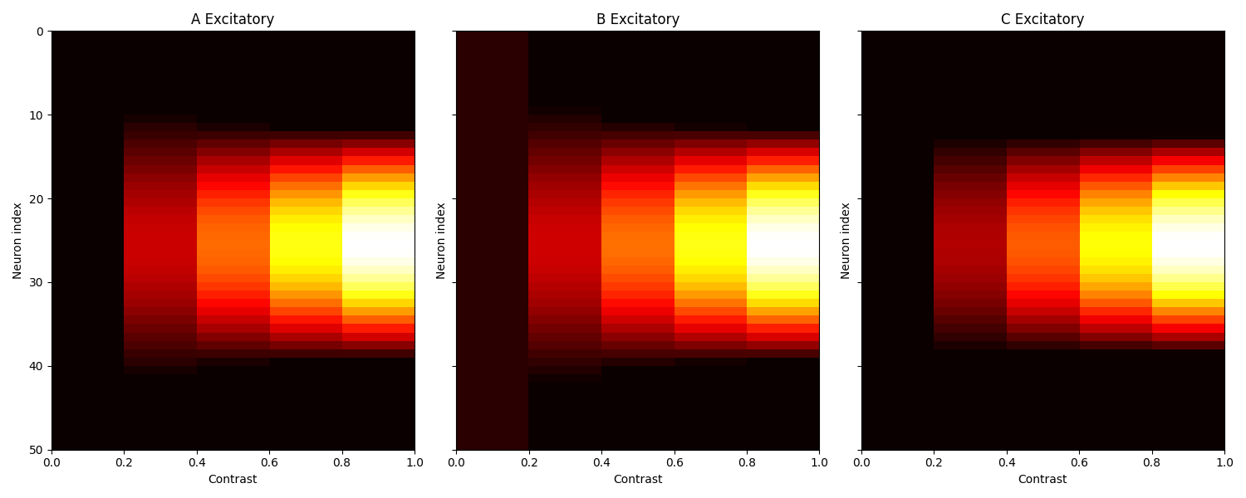

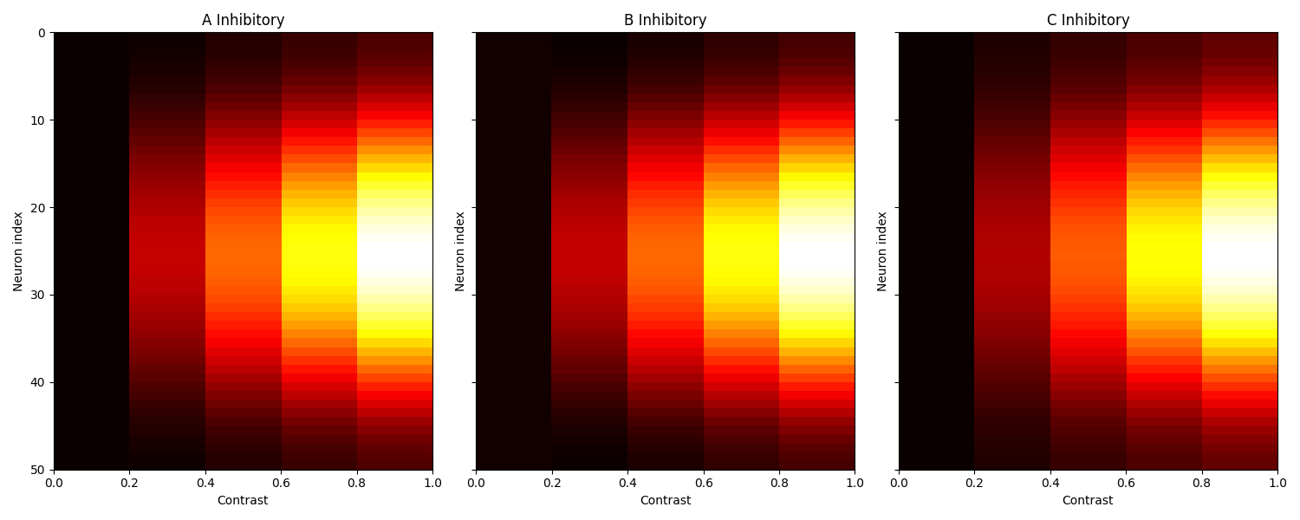Firing rates at final simulation time for excitatory neurons across contrasts.

Interpretation: All networks show stronger responses with increasing contrast. It looks like C has sharper, centered tuning. More inhibitory units have feedback than excitatory units generally.

## Step 4 – Mean-normalized heatmaps

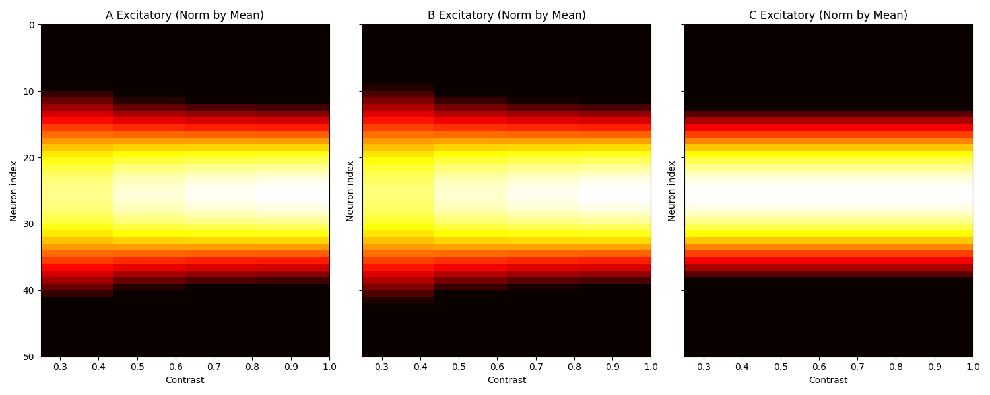

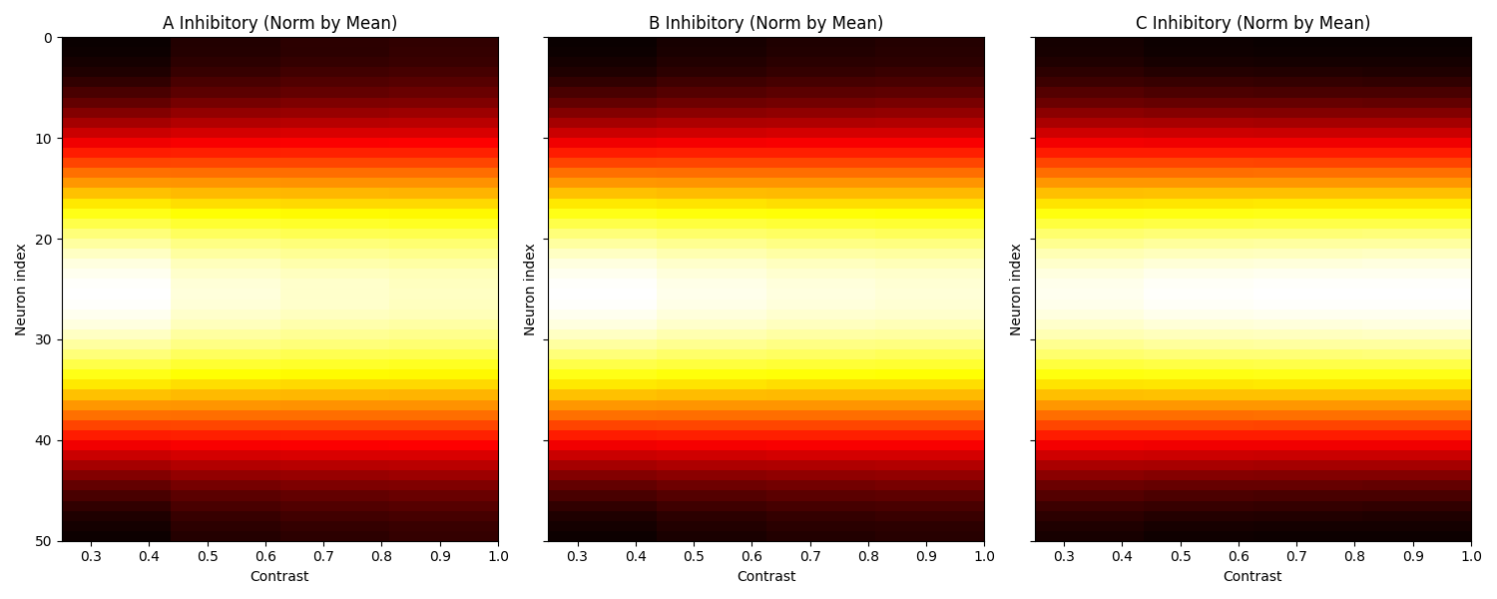The figures use the same data as Q3 but normalized by mean firing rate per contrast to assess contrast invariance.

Compared to step 3, rescaling by means made the responses more identical between contrasts.

Comparing networks, network C maintains consistent tuning shape, showing contrast-invariant scaling in excitatory responses, and the results look very similar in inhibitory ones.

## Step 5 – Orientation tuning heatmaps

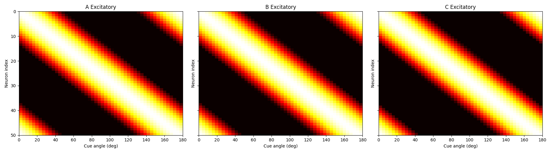

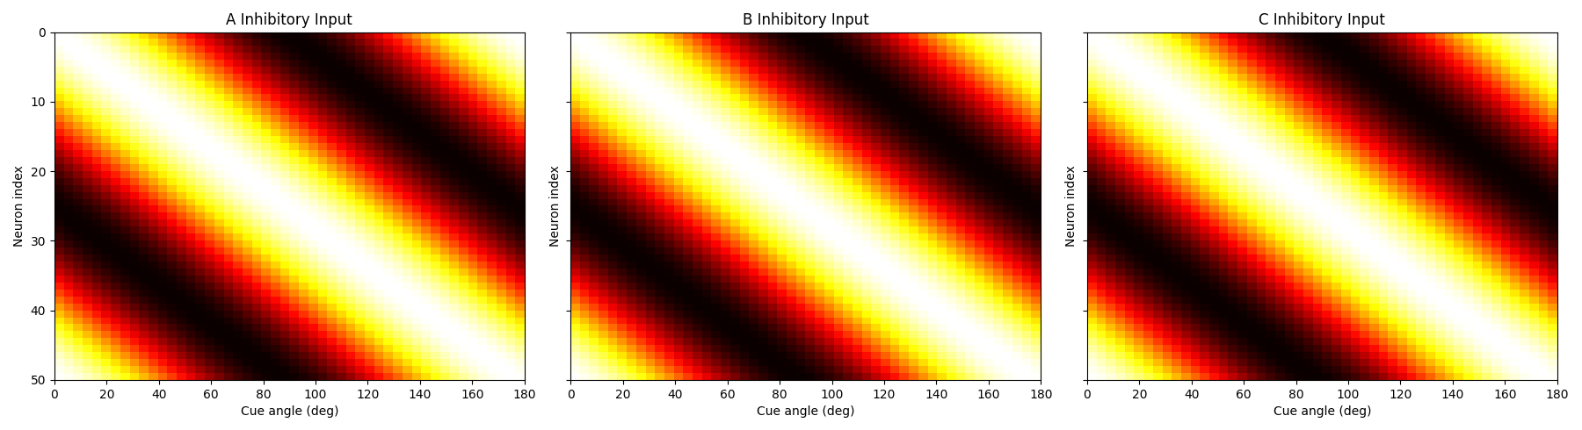Each neuron’s normalized response to 50 cue angles (0 to π). Built by simulating fixed contrast for each angle, fir excitatory and inhibitory ones.

Inhibitory units show broader and stronger responses.

Neurons fire most at their preferred angle. I could hardly tell the difference between networks in terms of response pattern. So I would say all three models align with the finding that inhibition, as well as excitation, peak at a neuron's preferred stimulus orientation.

## Step 6 – Tuning curve of a single neuron

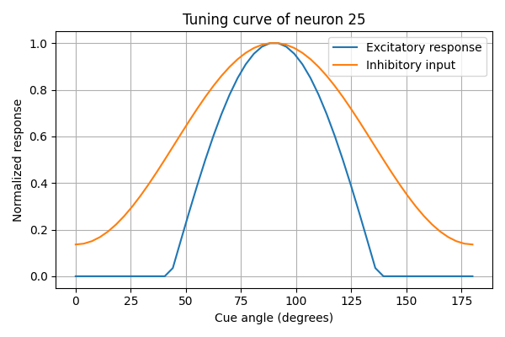

The graph shows Neuron 25's normalized excitatory and inhibitory responses vs. stimulus angle.

Both curves peak at the same angle (π/2) while inhibition is broader than excitation.

I think if we only simulate one neuron with different angles, the tuning curve provides quite straightforward results, a normal curve which peaks at a specific orientation. But it does not provide a full picture of how a series of neurons with different preferred orientations respond to stimuli.